PT 5210/913 VariTime Digital Sync Generator

and

PT8603/910 SDI Test signal Generator

Supplement to: PT 5210 Reference: Manual no. 9499 491 02211

The supplement describes the modifications made to the standard instrument.
This supplement also covers the update PROM kit: 9449 900 22001

Feature: Moving text in the SDI signals for revealing “frozen” transmission lines or processes.

PT 5210/913
Software in the PT5210/913 has been modified to allow for moving text feature in PT8603/910.
The text menu contains now “Text ON/OFF” only. The remote interface commands are unchanged.
Master software version is 3.5.

Position: | Code number | Checksum
V403 | 4008 119 60641 | DCEF
For positioning of the processor please refer to photo below:
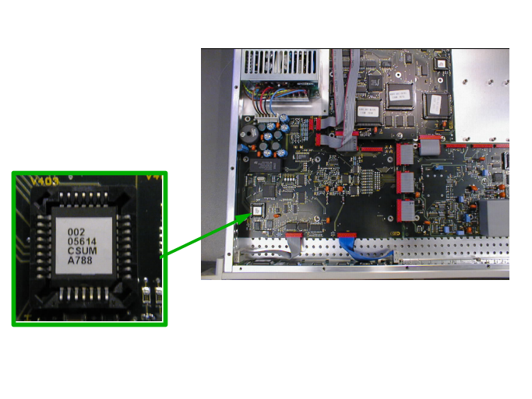

PT 8603/910
- Text, if ON, moves vertically, and scroll from line 48 to 100 (first line in black backgound).
- The text scrolls up and down slowly at a rate of 1 line per field.
- Text is placed in the blue and red bars in the colorbar
- Text may be ON or OFF.
Software version is 3.8
New PROM installed.

Position: | Code number | Checksum
V53 | 4008 119 60642 | 7307

For positioning of the processor please refer to drawing below:
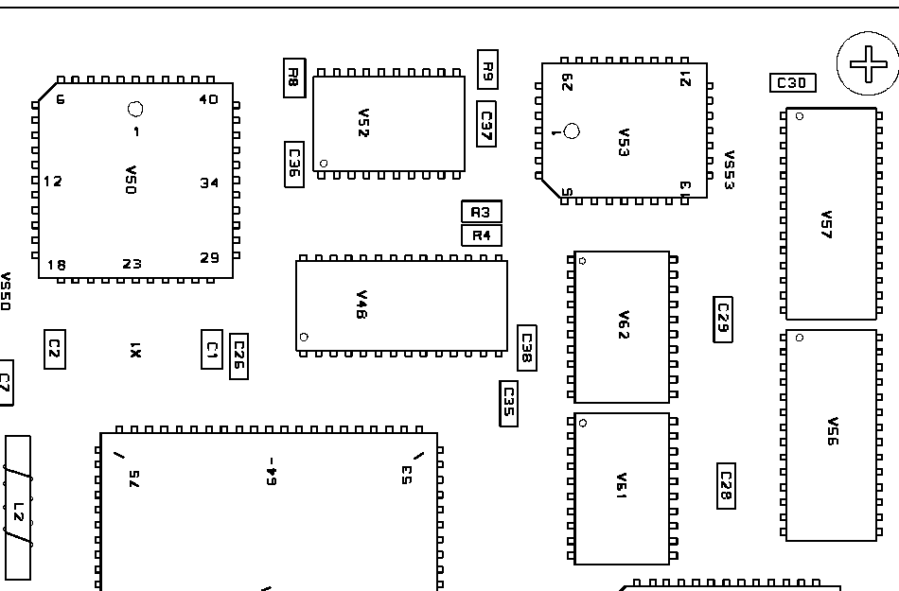
V53

